**WEB ANALYTICS**

**ASSIGNMENT - 1**

*Submitted By*:

Sanskruti Jain

Manoj Thadani

Bhavisha Mehta

Rounak Burad

Geethika Veluri

Ankita Wadhwa

Group ID:group1webanalytics@gmail.com

**ACCOUNTING**

**Time range of analysis:** Aug 1, 2016 to Dec 31, 2016

The Accounting segment created for analysis has the below condition:

**CONDITION 1:** Sessions include: **Page contains** /Accounting

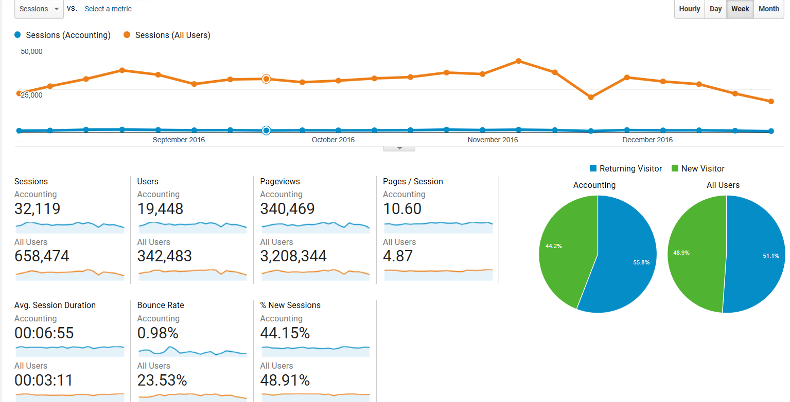

**Observations:**

1.The number of sessions are observed to have decreased in the last week of November and last two weeks of December for All users and Accounting. This could be due to the holiday season.

2. The bounce rate of the Accounting department is very less compared to the overall users.

3. The number of pages/session is 10.6 for the Accounting department and 4.87 for the All users segment. Also, the and the Avg. session duration are much higher for the accounting department when compared to the all users.

**Recommendation:**

The content for the Accounting might not be well structured which is causing the students to spend more time on the website. So JSOM should make the content more structured on the website for Accounting.

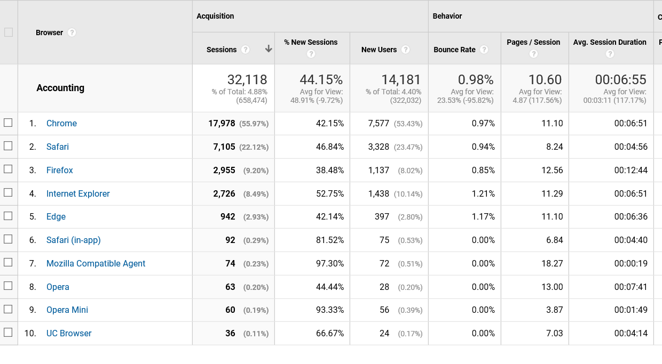

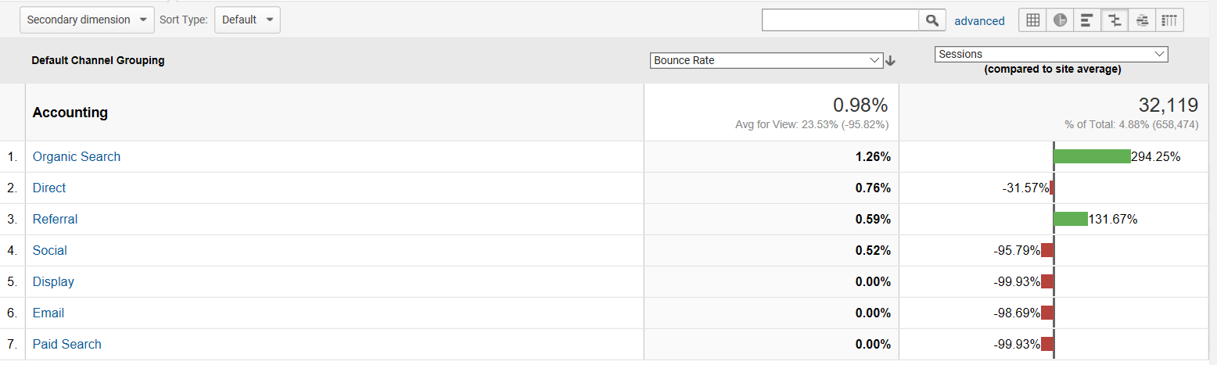

**Observations and Recommendations:**

The highest percentage of sessions happen on the chrome followed by safari and Firefox. Of all the browsers Internet Explorer has the highest bounce rate and highest % of new sessions. This means that Internet Explorer is technically less compatible when compared to the other browsers. The interface and page loading time should be improved for the website when accessed through Internet Explorer.

Referral channel has the second highest percentage of sessions. It is seen that the bounce rate for referrals is very less. It is recommended that more traffic is diverted to the website through referral channels.

**FINANCE AND MANAGERIAL ECONOMICS**

**Time range of analysis:** Aug 1, 2016 to Dec 31, 2016

The finance segment created for analysis has the below condition:

**CONDITION 1:** Sessions include: **Page contains** /finance

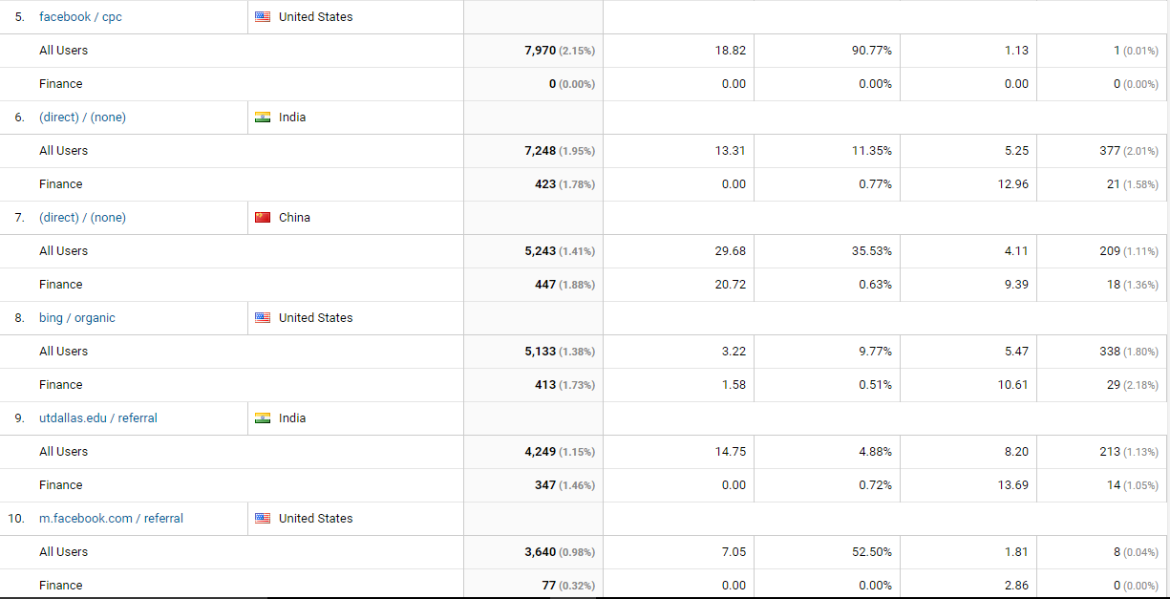

**Observations and Recommendations:**

From the information provided in above screen shot we have analyzed the traffic source and medium based on the countries. We notice that finance contributes 6.60% of the total users. One interesting observation from the screenshot below is that Facebook ads do not contribute any traffic towards the finance programs in USA. Also, the bounce rate for Facebook ads for All Users is very high at 90.77%. This is surprising and JSOM should not undertake any marketing campaign for its finance programs or any other programs on Facebook. It should stop its campaign on Facebook. The Finance program is hugely popular in USA and moderately in India and China respectively. JSOM should target US citizens; it should spend more dollars in digital marketing campaigns in USA. This can be inferred from the traffic source such as Google, direct or referred by utdallas.edu

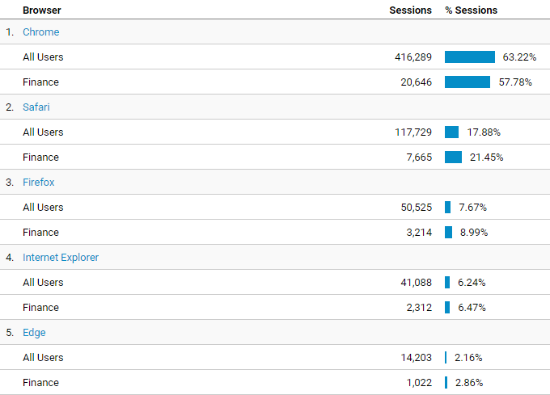

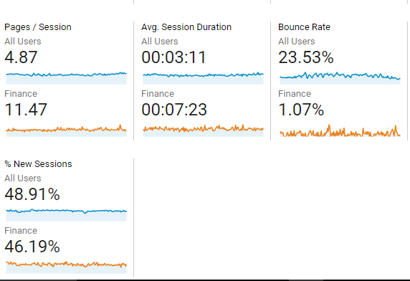

**Observations and Recommendations:**

We have done a brief overview of the audience and the type of browsers used by them as seen in the above picture. Widely used browsers in the following order are Chrome, Safari, Firefox and Internet Explorer for both all users and for those who searched for any program related to finance. Hence UTD should optimize the content for these browsers and also reduce the bounce rate, average page load time for these browsers. Also the average session duration for Finance is better than all other programs and the bounce rate is extremely low as compared to other programs. Even pages/session (page depth) is way better than other programs. The content on pages containing Finance is highly optimized as compared to other pages. JSOM should optimize the content for other programs so as to better engage other users and should leave the Finance program untouched.

**INFORMATION SYSTEMS AND OPERATIONS MANAGEMENT**

**Time range of analysis:** Aug 1, 2016 to Dec 31, 2016

The ISOM segment created for analysis has the below condition:

**CONDITION:** Sessions include: **Page contains** /ISOM

The below table shows the Average Page Load Time (in seconds) compared to the Site Average for the ISOM Section of the website:

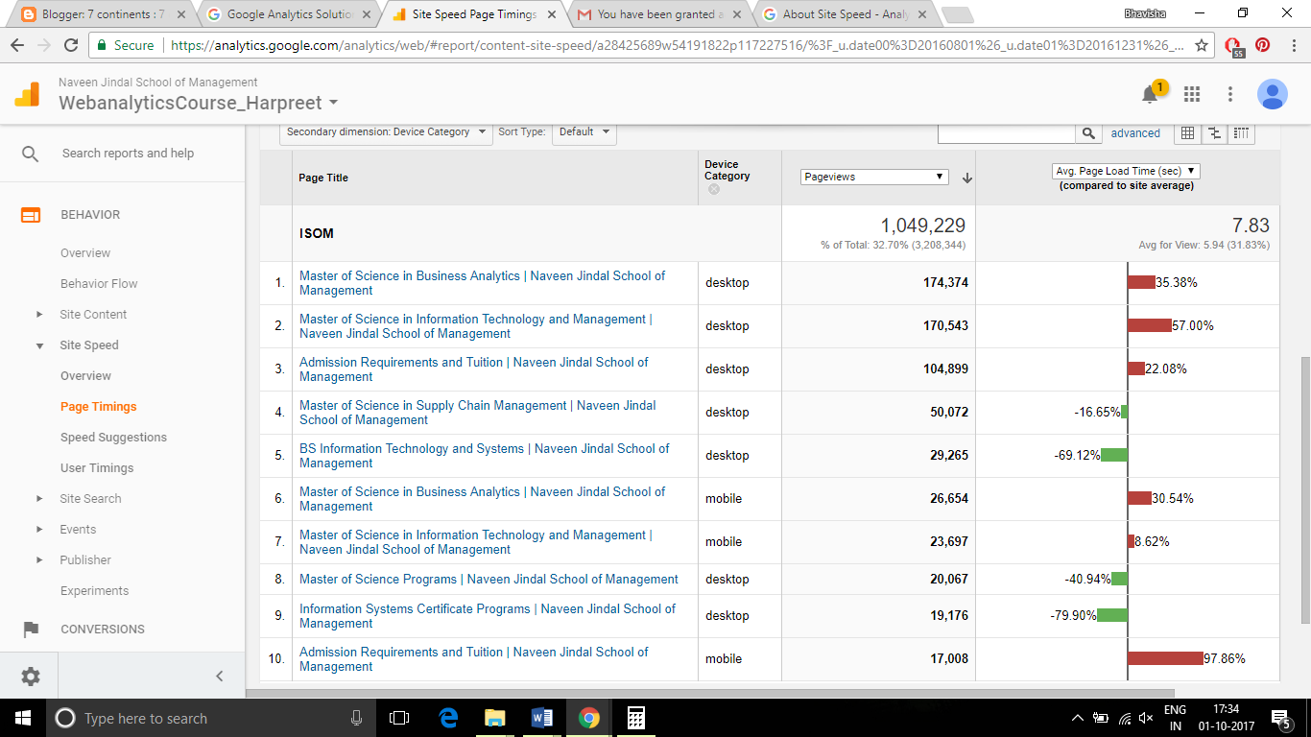

**Observations and Recommendations:**

According to the above report, we can see the following three pages:

* Master of Science in Business Analytics
* Master of Science in Information Technology and Management
* Admission Requirements and Tuition

Despite being the most viewed pages in the ISOM section of the website, their average page load time is much higher than the Site average. This information is concerning because users usually have low tolerance for pages that take long time to load, which eventually results in page exits. It is recommended to identify and fix the factor causing this (which may be because of high Domain Look-up Time, Page download time, Redirection Time, etc)

We can also see that the MS ITM page takes higher amount of time to load on desktop than on mobile; On the contrary Admission Requirements and Tuition page takes much longer to load on mobile devices as compared to desktop. The website should be made compatible with each other device categories to make it a smooth experience for the user.

The following report shows the page exits of each page:

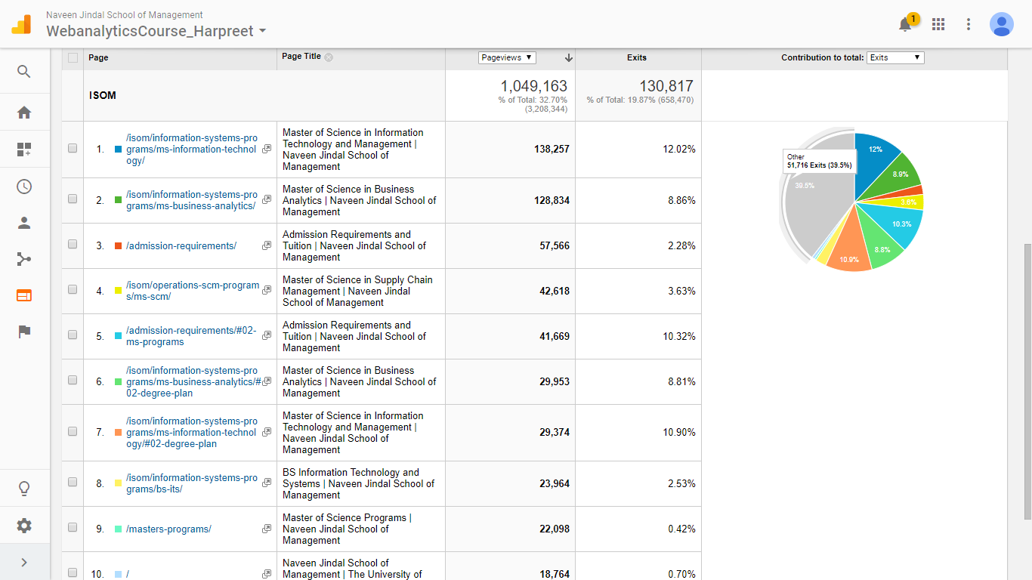

**Observations and Recommendations:**

We can see that three out of the five most visited pages face the highest percentage of exits. Such high frequency of exits indicates that even though high attention is drawn towards these pages, it is unable to engage the users and lead them to further browsing of the website.

It is recommended to modify the page and improvise its content so as to keep the users engrossed. This can be done by adding more relevant information in an efficient and attractive manner.

**MARKETING**

**Time range of analysis:** Aug 1, 2016 to Dec 31, 2016

The Marketing segment created for analysis has the below condition:

**CONDITION:** Sessions include: **Page contains** /Marketing

The below table displays the page information associated with the marketing section of the website.

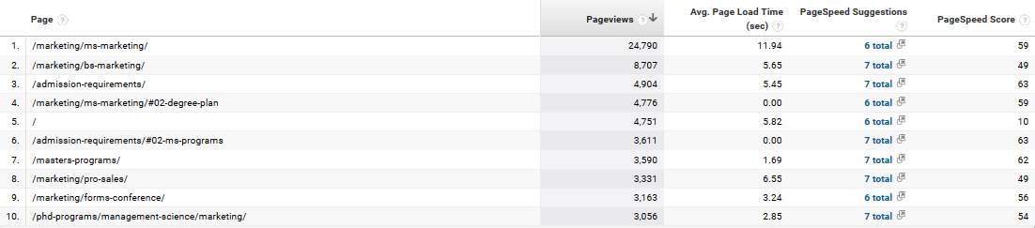

**Observations and Recommendations:**

As per the above report, /marketing/ms-marketing/page and /marketing/bs-marketing page are the two most popular pages in the Marketing section. As can be seen, their average page load time is higher compared to the site average. Higher loading time is the main factor in decreased engagement of a page since a user does not have enough patience. This data also tells us the page score which are determined after the page test. A high page score is usually co-related to a faster user experience. For a better page score, optimization of a page is the most important thing.

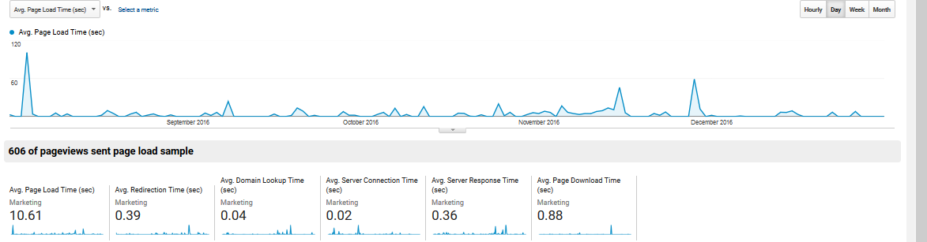

**Recommendations:**

Average page load time should always be low so that it does not affect the customer satisfaction. Faster the page loads onto your browser, better the customer experience.

1. Optimize images:

In most cases, the images on a webpage are the major reasons for high page load times. Reducing the image size drastically will eventually reduce the weight of the page.

1. Minify JavaScript and CSS:

Compacting CSS code and JavaScript code can save many bytes of data and speed up download and parse times.

1. Prioritize visible content:

For best performance, reduce the amount of HTML needed to render above-the-fold content.

1. Avoid landing page redirects:

Redirects trigger an additional HTTP request-response cycle and delay page rendering. Avoid having more than one redirect from the given URL to the final landing page.

**ORGANIZATIONS, STRATEGY AND INTERNATIONAL MANAGEMENT**

**Time range of analysis:** Aug 1, 2016 to Dec 31, 2016

The OSIM segment created for analysis has the below condition:

**CONDITION:** Sessions include: **Page contains** /OSIM

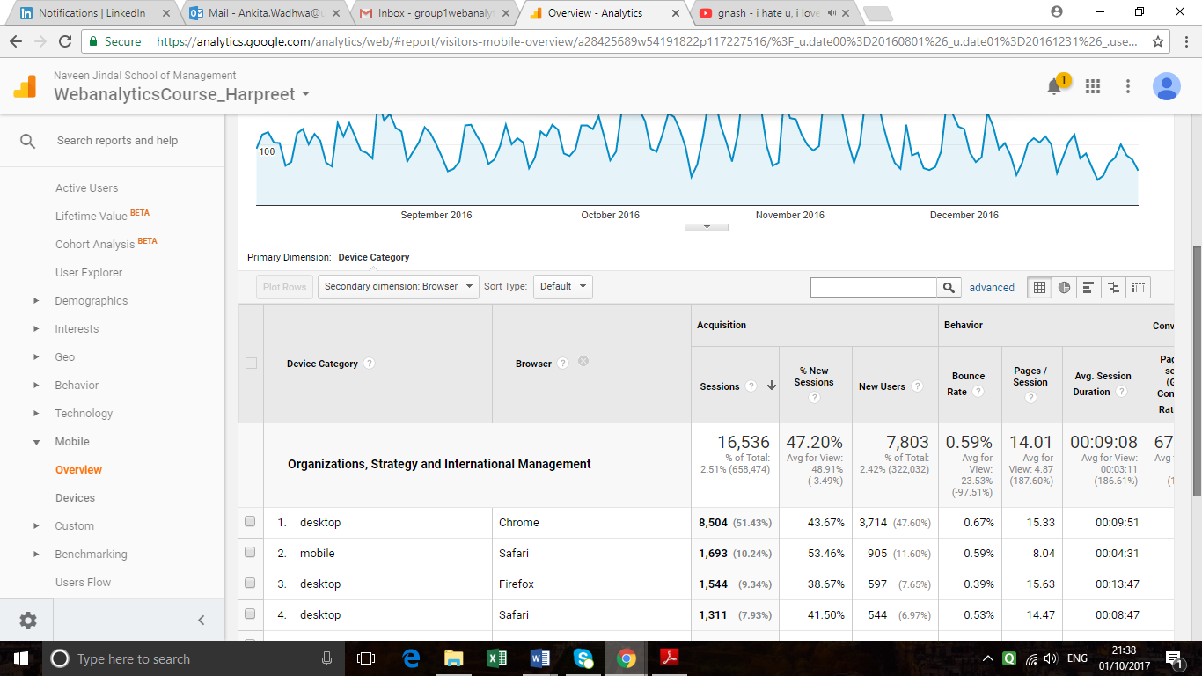

**Observation and Recommendation:**

Analysing the above report, we can see that most users are using Desktop as their device and Chrome as their browser. Moreover, the bounce rate for the chrome is the highest, among all the browsers.

Fixing the compatibility issues with the Chrome browser might generate more traffic on the osim page, thereby reducing bounce rate.

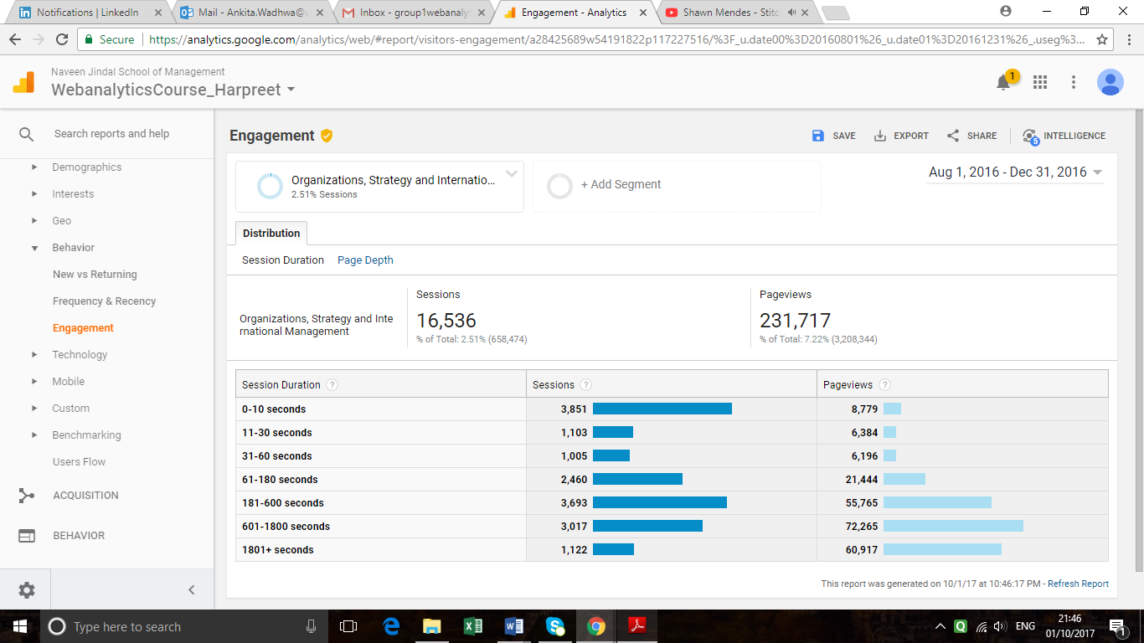

**Observations and Recommendations**

Above report shows for how long the users are engaged with the OSIM page. Maximum number of users is only engaged for 0-10 seconds, which is indication that users are not getting what they are looking for.

Add relevant information, course structure, and course content and career prospects of the course more to increase user engagement and user attention. We can then have users spending at least 180 seconds on the page and hence, improving the engagement.

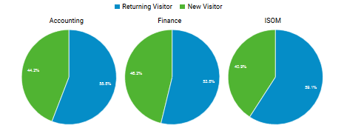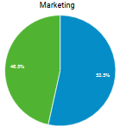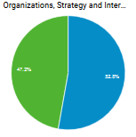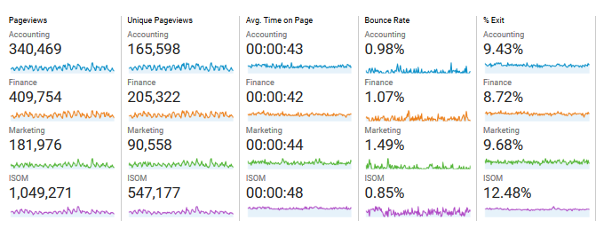**COMPARISON OF THE VARIOUS SEGMENTS**

**Observations:**

* Relative to other departments the bounce rate of marketing is higher which might be due to the longer time to load
* ISOM deems to be the most popular choice of course among all the courses that are on offer judging from its number of pageviews.
* Marketing has the least number of pageviews suggesting that people either aren’t aware of the course or are not as interested in it as compared to other courses
* OSIM and Finance have the least average time on page suggesting that people either don’t spent time on these pages or the retrieval of data on these pages are very fast which suggests that the pages are optimized.
* %Exit is high along with the high average time on page for ISOM which suggests that people usually find what they are searching for on this page.